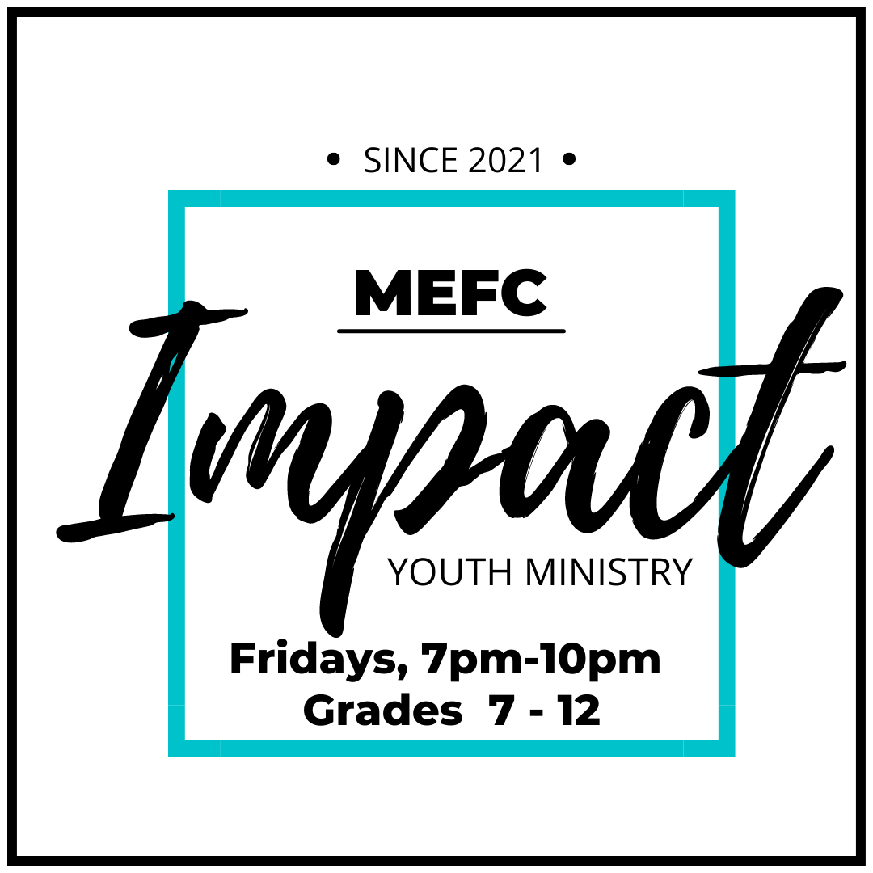

REGISTRATION CONTENTS:

- Welcome Letter to Parents
- MEFC Youth Plan
- Parental Consent/Waiver Sign & Return
- MEFC Youth Code of Conduct Sign & Return
- MEFC Youth Registration Form Fill & Return
- Parent Volunteer Form *Optional*

Please keep the pack for your records, only returning the required forms.

September 2023

Dear Parents

Thank you for your involvement and the participation of your son or daughter at IMPACT - Manitou Evangelical Free Church’s Youth Ministry, specifically Friday night youth group.

We look forward to another great year of activities and fun. We have our events calendar planned but are subject to change due to weather or unforeseen circumstances, so we ask that you and your teen(s) follow on our social media platforms to always be informed. We will do our best to communicate often and clearly with you and your teens.

Friday night youth group is open to Grades 7 - 12, consisting of two main groups:

- JR YOUTH – Grades 7 - 9
- SR YOUTH – Grades 10 - 12

Our events are for all. Events geared to specific group is always identified on the event posting.

Our desire is that Friday night youth group be a positive and safe community for all those attending and to enjoy times of getting to know each other, fun and learning, as well as opportunities to serve our community and surrounding areas.

As part of our plan to help keep everyone safe, included is our registration/waiver pack. Please read carefully, sign and return forms upon arrival. This is a ONE-TIME registration form to be completed by each participant for the year. If Parent/Guardian/Emergency Contact info is the same for multiple members of a family, the required info on at least the eldest family member’s form is fine.

Included with the registration forms is our Code of Conduct, which we would appreciate you going over with your youth. We require parent and youth to sign it, indicating both have read and agree to it, allowing for the best experience for all. Failure to comply could lead to consequences.

Thanks again for sending your teen to MEFC youth group. Please don’t hesitate to contact MEFC youth point person, Luanne Jones, or the church office at 306-823-4363. For any questions or concerns you may also reach us at mefc@sasktel.net.

Follow us for ALL events and details:
Website: www.manitouefc.com
Facebook Group: IMPACT - MEFC Youth Ministry
Instagram: mefc_youth

MEFC YOUTH PLAN

- Complete registration forms are required upon attending MEFC Youth Group. It is a one-time fill. No youth will be allowed to attend any event without prior registration, that includes guests.

Completed forms may be dropped off at MEFC Tues-Fri 9am-3pm or given to a youth leader. You may also scan or email to mefc@sasktel.net

- Friday Night Youth Group is held weekly, from 7:00pm – 10:00pm, unless, otherwise posted. Rides provided from MEFC will leave at 6:45pm.
*Licensed youth will not be permitted to drive for events*

- Mandatory Sign-in and Sign-out procedure at every event. Students who leave before 10pm will need to provide MEFC leadership with proof of consent or a call will be made to contact person listed on registration.

- Youth Events will vary week to week. All events will be posted on our social media outlets. Events could be open to all youth grades 7 – 12 but could specify whether just geared to SR Youth or JR Youth. See posts for details.

- Snack is provided at each event.
*We are unable to accommodate special dietary restrictions*

PARENTAL CONSENT/ASSUMPTION OF THE RISK AND WAIVER OF LIABILITY AGREEMENT
– PLEASE READ CAREFULLY; INITIAL EACH AND SIGN TO COMPLETE –
I hereby give consent for my child(ren) to attend and participate in all activities sponsored by the Manitou Evangelical Free Church Youth Ministry. __________

I understand that the youth group includes physical activity in the form of a variety of sports and recreational activities. I am aware and understand the possibility of unforeseen hazards and know the inherent possibility of risks. I agree that Manitou Evangelical Free Church will not be held liable for any injury to my child(ren), or loss or damage to my child’s personal property. As part of these activities, authorization and permission is hereby given to MEFC youth group leaders/volunteers for transportation of my child(ren) to and from events offered. __________

In case of emergency, I understand every effort will be made to contact myself. In the event that I cannot be reached in an emergency situation, I hereby give permission to licensed emergency and health care personnel to provide treatment, services and transport necessary to maintain the health of my child. In the event medication, medical advice, treatment and/or equipment are required, I agree to accept financial responsibility for fees in excess of provincial and or private medical insurance. I agree that the information on this form may be disclosed to such emergency and health care personnel. In the event of illness, accident, emergency, or any other circumstance requiring medical treatment, such treatment may be procured for the participant without legal or financial obligation to Manitou Evangelical Free Church.__________

In consideration of my child(ren)’s participation in the Manitou Evangelical Free Church youth ministry, I, the parent/guardian, on behalf of myself and on behalf of my child(ren), HEREBY DO RELEASE Manitou Evangelical Free Church, its officers, directors, employees, volunteers, representatives, insurers and agents (collectively, the “Releasees”) from any and all liabilities, claims, actions, demands, costs and expenses relating to injury, illness, death, loss, damage to person or property or loss of property, foreseen or unforeseen, howsoever caused (including any negligence of any one or more of the Releasees), arising out of or in connection with my child(ren)’s participation in the Manitou Evangelical Free Church youth group. __________

I also agree to indemnify and hold harmless the Releasees for any and all causes of action, claims, demands, losses or costs of any nature whatsoever arising out of or in any way related to my child’s participation in the MEFC youth ministry/group. _________

All known health issues of my child have been stated to Manitou Evangelical Free Church. I will notify MEFC youth leaders of any changes. __________

I agree to allow photographs or video of youth group activities, which may include my child(ren), to be used in youth group promotional material including without limitation brochures, CDs, DVDs, website and newsletters. __________

Manitou Evangelical Free Church reserves the right to request any participant to withdraw from the youth group activity if the participant is not acting in an appropriate and responsible manner.

I have read and understood the terms of this agreement and BY ALLOWING MY CHILD(REN) to participate in the MEFC youth ministry, I am voluntarily agreeing to abide by these terms.

I understand and agree that my signature below represents a signature on behalf of myself and my child(ren).

Parent/Guardian Name (Printed): _________________________________________________

Parent/Guardian Signature: ______________________________________________________

Date: ______________________

Name of child(ren):

_______________________________________________

_______________________________________________

_______________________________________________

_______________________________________________

_______________________________________________

_______________________________________________

_______________________________________________

MEFC YOUTH CODE OF CONDUCT

Each person participating in any MEFC youth ministry is expected to abide by the following Code of Conduct. This includes leadership, youth attendees, regular and visitors.

Remember that your words and actions should reflect Christ. By participating in the MEFC youth ministry, you represent Christ, the church, your parents and yourself. What you say and do has impact on others; it is our desire that your impact be a positive one.

1. Respect – as we enjoy activity, times of learning and times of serving together, we commit to respecting all other members of the youth group and leaders in the way we talk and act towards one another. We also agree to respect the leaders, not only as they lead and oversee events, but during times of speaking and teaching, giving them the attention, courtesy and respect due during their time, and to respect the property that we will be trusted with (both at the church or other locations where events may take place, including transportation).

2. Attendance – For safety and well-being of all students, there will be a mandatory Sign-in and Sign-out procedure at all events. If you need to leave before the end of an event and no arrangements made aware to a leader, a parent or guardian listed as contact will be called to confirm that permission has been granted.

3. Appropriate Dress – out of respect for yourself and others, we ask all members of the youth group to avoid clothing with offensive words or logos, mini cropped tops, see through clothing, short skirts or shorts, saggy pants or bikinis for swimming events. We also ask that you come dressed appropriately for the event and weather (ie. Outdoor winter clothes for an outside winter activity).

4. Cell Phones – cell phones and other electronics will be permitted at your own risk (risk of damage, theft or loss). ***During devotional times, out of respect to the person leading the discussion and during some youth events, leaders will ask that phones and other electronics be put away during that segment of the evening. Leaders may be contacted in case of emergency. A list will be provided.

5. Public Display – Inappropriate display of affection will not be tolerated. It should be known that inappropriate physical contact among members of the youth will not be tolerated. This would include, but is not subject to just the following -“hanging on” someone, sitting on another’s laps, kissing, hand-holding, or un-necessary behavior between youth, whether perceived to be friendly or romantic.

At no time will the leadership/volunteers of MEFC youth tolerate language or behavior that is disrespectful or unsafe. No obscene language, drugs, alcohol, tobacco, vaping or weapons of any kind on MEFC property or present at any MEFC youth event. Failure to comply could lead to consequences.
CODE OF CONDUCT ADHERENCE

As a parent or guardian of a student(s) at the Manitou Evangelical Free Church youth group, I have read and understand MEFC’s Youth Group Code of Conduct. I support the Code of Conduct and expect my child(ren) to always adhere to it.

Parent’s Name: _____________________________ Date:________________________

Parent’s Signature: ________________________________________

*** ADDITIONAL BOXES AVAILABLE FOR MULTIPLE STUDENTS PER HOUSEHOLD ***

I have read and understand MEFC’s Youth Group Code of Conduct and will abide by it.

Student’s Name: _____________________________ Date:________________________

Student’s Signature: ________________________________________

I have read and understand MEFC’s Youth Group Code of Conduct and will abide by it.

Student’s Name: _____________________________ Date:________________________

Student’s Signature: ________________________________________

I have read and understand MEFC’s Youth Group Code of Conduct and will abide by it.

Student’s Name: _____________________________ Date:________________________

Student’s Signature: ________________________________________

I have read and understand MEFC’s Youth Group Code of Conduct and will abide by it.

Student’s Name: _____________________________ Date:________________________

Student’s Signature: ________________________________________

I have read and understand MEFC’s Youth Group Code of Conduct and will abide by it.

Student’s Name: _____________________________ Date:________________________

Student’s Signature: ________________________________________

MEFC YOUTH GROUP REGISTRATION FORM

STUDENT INFORMATION
FIRST NAME __________________________ LAST NAME _________________________
DATE OF BIRTH ______________________ CELL NUMBER ________________________
PROVINCIAL HEALTH CARD NUMBER_________________________ (in case of emergency only)

ANY ALLERGIES OR SERIOUS MEDICAL CONDITIONS:

PARENT/GUARDIAN
FIRST NAME _________________________ LAST NAME__________________________
CELL NUMBER _______________________ HOME NUMBER ______________________
EMAIL ______________________________

FIRST NAME _________________________ LAST NAME__________________________
CELL NUMBER _______________________ HOME NUMBER ______________________
EMAIL ______________________________

EMERGENCY CONTACT INFORMATION
Someone we could contact in case of emergency when parents cannot be reached
FIRST NAME _________________________ LAST NAME __________________________
CELL NUMBER _______________________ HOME NUMBER ______________________
RELATIONSHIP TO STUDENT ____________________________

* FILL OR MAKE COPIES OF NEXT PAGE FOR MULTIPLE STUDENTS PER HOUSEHOLD *
STUDENT INFORMATION

FIRST NAME __________________________ LAST NAME _________________________
DATE OF BIRTH ______________________ CELL NUMBER ________________________
EMAIL ADDRESS _________________________
PROVINCIAL HEALTH CARD NUMBER_________________________ (in case of emergency only)

ANY ALLERGIES OR SERIOUS MEDICAL CONDITIONS:

- SAME PARENT/GUARDIAN/ EMERGENCY CONTACT INFO AS SIBLING

STUDENT INFORMATION
FIRST NAME __________________________ LAST NAME _________________________
DATE OF BIRTH ______________________ CELL NUMBER ________________________
EMAIL ADDRESS _________________________
PROVINCIAL HEALTH CARD NUMBER_________________________ (in case of emergency only)

ANY ALLERGIES OR SERIOUS MEDICAL CONDITIONS:

- SAME PARENT/GUARDIAN/ EMERGENCY CONTACT INFO AS SIBLING
PARENT VOLUNTEER FORM

PARENT/GUARDIAN INFORMATION
FIRST NAME __________________________ LAST NAME _________________________
CELL NUMBER ________________________

EVENT DRIVER
If extra drivers are needed for the transportation of youth to/from events sponsored by the Manitou E Free Church youth ministry, I am a willing and licensed driver. YES NO

Upon request, I will provide proof of my valid driver’s license. YES NO

- I understand that I am volunteer driver, and bound by all expectations and policies that would be in place for Manitou Evangelical Free Church youth leaders.

- I agree to abide and follow all regulations by the requirements of The Highway Traffic Act and the SGI vehicle safety handbook and traffic bylaws while acting as a volunteer driver.

Parent/Guardian Signature: ________________________________________________

SNACK PROVIDER
I would like to contribute to the snack schedule for Friday night youth group. A snack menu can be provided and are designated for events. Dry goods can be purchased ahead of time or dropped at the church during office hours or on Friday nights. YES NO

