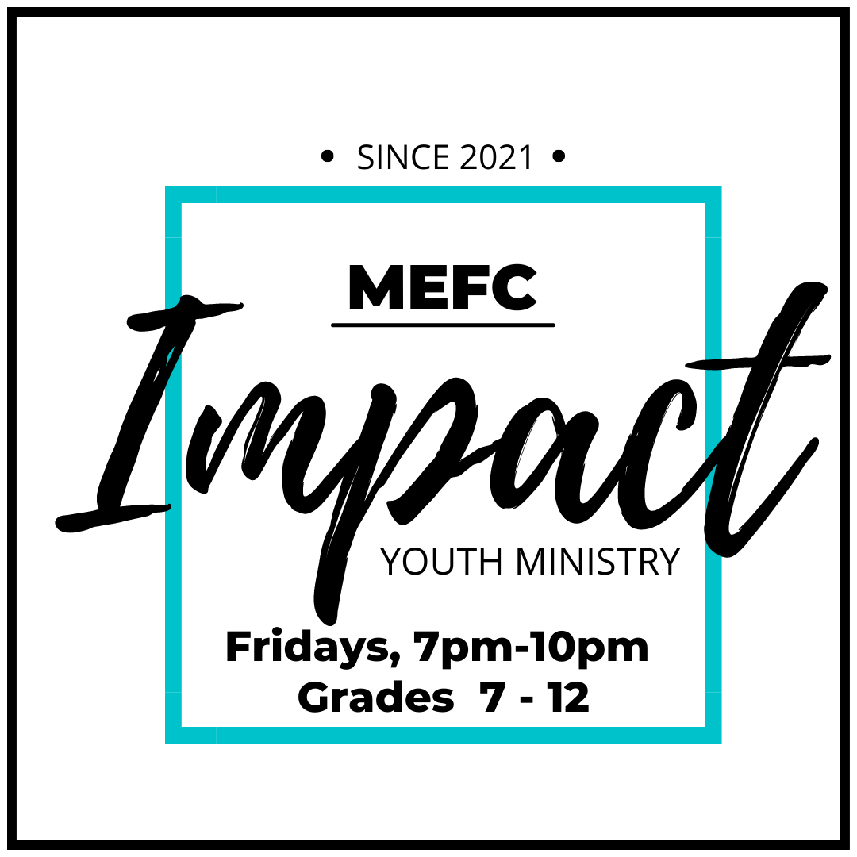

October 2025

Dear Parents

Thank you for your involvement and the participation of your son or daughter at IMPACT - Manitou Evangelical Free Church’s Youth Ministry, specifically Friday night youth group.

We look forward to another great year of activities and fun. We have our events calendar planned but are subject to change due to weather or unforeseen circumstances, so we ask that you and your teen(s) follow on our social media platforms to always be informed. We will do our best to communicate often and clearly with you and your teens.

Friday night youth group is open to all students in Grades 7 - 12, consisting of two main groups:

- JR YOUTH – Grades 7 - 9
- SR YOUTH – Grades 10 - 12

Our desire is that Friday night youth group be a positive and safe community for all those attending and to enjoy times of getting to know each other, fun and learning, as well as opportunities to serve our community and surrounding areas.

As part of our plan to help keep everyone safe, included is our registration/waiver pack. Please read carefully, sign and return forms upon arrival. This is a ONE-TIME registration form to be completed by each participant each year; regardless if previously attended. If Parent/Guardian/Emergency Contact info is the same for multiple members of a family, the required info is required on just one family member’s form.

Included with the registration forms is our Code of Conduct, which we would appreciate you going over with your youth. We require parents and youth to sign it, indicating both have read and agree to it, allowing for the best experience for all. Failure to comply could lead to consequences.

Thanks again for sending your teen(s) to MEFC youth group. Please don’t hesitate to contact MEFC youth point person, Luanne Jones, or the church office at 306-823-4363. For any questions or concerns you may also reach us at mefc@sasktel.net.

Follow us for ALL events and details:
Website: www.manitouefc.com
Facebook Group: IMPACT - MEFC Youth Ministry
Instagram: mefc_youth

PARENTAL CONSENT/ASSUMPTION OF THE RISK AND WAIVER OF LIABILITY AGREEMENT
– PLEASE READ CAREFULLY; INITIAL EACH AND SIGN THE BACK TO COMPLETE FORM –

I hereby give consent for my child(ren) to attend and participate in all activities sponsored by the Manitou Evangelical Free Church Youth Ministry. I understand there is a mandatory Sign-in and Sign-out for each event. Students leaving prior to the end of the event will require consent from a parent. __________

I understand that the youth group includes physical activity in the form of a variety of sports and recreational activities. I am aware and understand the possibility of unforeseen hazards and know the inherent possibility of risks. I agree that Manitou Evangelical Free Church will not be held liable for any injury to my child(ren), or loss or damage to my child’s personal property. As part of these activities, authorization and permission is hereby given to MEFC youth group leaders/volunteers for transportation of my child(ren) to and from events offered. *Youth are NOT allowed to drive themselves to events unless consent from parents but absolutely NO passengers who are not immediate family members. __________

In case of emergency, I understand every effort will be made to contact myself. In the event I cannot be reached in an emergency, I hereby give permission to licensed emergency and health care personnel to provide treatment, services and transport necessary to maintain the health of my child. In the event medication, medical advice, treatment and/or equipment are required, I agree to accept financial responsibility for fees in excess of provincial and/or private medical insurance. I agree that the information on this form may be disclosed to such emergency and health care personnel. In the event of illness, accident, emergency, or any other circumstance requiring medical treatment, such treatment may be procured for the participant without legal or financial obligation to Manitou Evangelical Free Church.__________

In consideration of my child(ren)’s participation in the Manitou Evangelical Free Church youth ministry, I, the parent/guardian, on behalf of myself and on behalf of my child(ren), HEREBY DO RELEASE Manitou Evangelical Free Church, its officers, directors, employees, volunteers, representatives, insurers and agents (collectively, the “Releasees”) from any and all liabilities, claims, actions, demands, costs and expenses relating to injury, illness, death, loss, damage to person or property or loss of property, foreseen or unforeseen, howsoever caused (including any negligence of any one or more of the Releasees), arising out of or in connection with my child(ren)’s participation in the Manitou Evangelical Free Church youth group. __________

I also agree to indemnify and hold harmless the Releasees for any and all causes of action, claims, demands, losses or costs of any nature whatsoever arising out of or in any way related to my child’s participation in the MEFC youth ministry/group. _________

All known health issues of my child have been stated to Manitou Evangelical Free Church. I will notify MEFC youth leaders of any changes. __________

I agree to allow photographs or video of youth group activities, which may include my child(ren), to be used in youth group promotional material including without limitation brochures, CDs, DVDs, website and newsletters. __________

Manitou Evangelical Free Church reserves the right to request any participant to withdraw from the youth group activity if the participant is not acting in an appropriate and responsible manner.

Back
I have read and understood the terms of this agreement and BY ALLOWING MY CHILD(REN) to participate in the MEFC youth ministry, I am voluntarily agreeing to abide by these terms.

I understand and agree that my signature below represents a signature on behalf of myself and my child(ren).

Parent/Guardian Name (Printed): _________________________________________________

Parent/Guardian Signature: ______________________________________________________

Date: ______________________

Name of Youth:

_______________________________________________

_______________________________________________

_______________________________________________

_______________________________________________

_______________________________________________

MEFC YOUTH CODE OF CONDUCT
MEFC recognizes its spiritual, moral and legal obligation to maintain a safe and secure environment for minors participating in programs and services and is committed to preventing harm to those entrusted to the care of the church. MEFC is also committed to a policy of zero tolerance for abuse and neglect within its programs and services. MEFC will take appropriate steps to reduce both the opportunity for and likelihood of abuse or neglect. MEFC requires and facilitates exemplary conduct of staff and volunteers engaged in child and youth programs.

Each person participating in any MEFC youth ministry is expected to abide by the following Code of Conduct. This includes leadership, youth attendees, regular and visitors.

Remember that your words and actions should reflect Christ. By participating in the MEFC youth ministry, you represent Christ, the church, your parents and yourself. What you say and do has impact on others; it is our desire that your impact be a positive one.

1. Respect – as we enjoy activity, times of learning and times of serving together, we commit to respecting all other members of the youth group and leaders in the way we talk and act towards one another. We also agree to respect the leaders, not only as they lead and oversee events, but during times of speaking and teaching, giving them the attention, courtesy and respect due during their time, and to respect the property that we will be trusted with (both at the church or other locations where events may take place, including transportation).

2. Attendance – For safety and well-being of all students, there will be a mandatory Sign-in and Sign-out procedure at all events. If you need to leave before the end of an event and no arrangements made aware to a leader, a parent or guardian listed as contact will be called to confirm that permission has been granted.

3. Appropriate Dress – out of respect for yourself and others, we ask all members of the youth group to avoid clothing with offensive words or logos, mini cropped tops, see through clothing, short skirts or shorts, saggy pants or bikinis for swimming events. We also ask that you come dressed appropriately for the event and weather (ie. Outdoor winter clothes for an outside winter activity).

4. Cell Phones – cell phones and other electronics will be permitted at your own risk (risk of damage, theft or loss). ***During devotional times, out of respect to the person leading the discussion and during some youth events, leaders will ask that phones and other electronics be put away during that segment of the evening. Leaders may be contacted in case of emergency. A list will be provided.

5. Public Display – Inappropriate display of affection will not be tolerated. It should be known that inappropriate physical contact among members of the youth will not be tolerated. This would include, but is not subject to just the following -“hanging on” someone, sitting on another’s laps, kissing, hand-holding, or un-necessary behavior between youth, whether perceived to be friendly or romantic.

At no time will the leadership/volunteers of MEFC youth tolerate language or behavior that is disrespectful or unsafe. No obscene language, drugs, alcohol, tobacco, vaping or weapons of any kind on MEFC property or present at any MEFC youth event. Failure to comply could lead to consequences.
CODE OF CONDUCT ADHERENCE

As a parent or guardian of a student(s) at the Manitou Evangelical Free Church youth group, I have read and understand MEFC’s Youth Group Code of Conduct. I support the Code of Conduct and expect my child(ren) to always adhere to it.

Parent’s Name: _____________________________ Date:________________________

Parent’s Signature: ________________________________________

*** EACH YOUTH NEED ONLY GIVE CONSENT AND SIGN ONE BOX ***

I have read and understand MEFC’s Youth Group Code of Conduct and will abide by it.

Student’s Name: _____________________________ Date:________________________

Student’s Signature: ________________________________________

I have read and understand MEFC’s Youth Group Code of Conduct and will abide by it.

Student’s Name: _____________________________ Date:________________________

Student’s Signature: ________________________________________

I have read and understand MEFC’s Youth Group Code of Conduct and will abide by it.

Student’s Name: _____________________________ Date:________________________

Student’s Signature: ________________________________________

I have read and understand MEFC’s Youth Group Code of Conduct and will abide by it.

Student’s Name: _____________________________ Date:________________________

Student’s Signature: ________________________________________

PARENT VOLUNTEER FORM

PARENT/GUARDIAN INFORMATION
FIRST NAME __________________________ LAST NAME _________________________
CELL NUMBER ________________________

EVENT DRIVER
If extra drivers are needed for the transportation of youth to/from events sponsored by the Manitou E Free Church youth ministry, I am a willing and licensed driver. YES NO

Upon request, I will provide proof of my valid driver’s license. YES NO

- I understand that I am volunteer driver and bound by all expectations and policies that would be in place for Manitou Evangelical Free Church youth leaders.

- I agree to abide and follow all regulations by the requirements of The Highway Traffic Act and the SGI vehicle safety handbook and traffic bylaws while acting as a volunteer driver.

Parent/Guardian Signature: ________________________________________________

SNACK PROVIDER
I would like to contribute to the snack schedule for Friday night youth group. A snack menu can be provided and is designated for events. Dry goods can be purchased ahead of time or dropped at the church during office hours or on Friday nights. YES NO

